**What is it like to be a military child?**

Carnagill Primary School is situated within Catterick Garrison, one of the largest military bases in Europe. As a result, 70% of our pupils come from military families and their lives are directly affected by this lifestyle.

*‘Military families have to: understand that ‘duty’ comes first, and operational effectiveness is the main priority; manage sometimes lengthy periods spent apart as a result of deployments; undertake frequent moves and relocations which entail disruptions in children’s education, health care and spousal/partner employment; and cope with tensions in balancing family life with the demands of Service life.’* **Living in Our Shoes Report, commissioned by the Ministry of Defence, June 2020**

Here are a few of the things our pupils have to say about being a service pupil…

“A benefit of moving around is getting to meet lots of people, but then you also end up having to leave them too.”

“It’s hard when you live far away from family because you can’t see them as often as you’d like.”

“It’s sad to wake up on Christmas or a birthday when your dad isn’t here. They’re family events and they just don’t feel normal without him.”

“It’s hard when a member of your family is away for an extended period of time, especially when they are not home for long before going away again.”

“In military houses you can’t decorate your room too much because you will get charged if you don’t put it back to how it was. I would like to be able to personalise my room more.”

“I felt nervous moving to another country because I didn’t have any friends and I was scared. I had to learn a new language and that was hard.”

For a smaller proportion of our military pupils, both parents are serving, or they are from a single-parent family, so when parents are deployed it is necessary for the children to move and stay with another family member for a significant period of time. This can mean that our pupils are dual educated and must adapt to another school before returning to Carnagill.

*‘The mobile lifestyle of the children we spoke to meant they faced a set of challenges largely unfamiliar to the settled community. Being part of a group of children experiencing these challenges together was important. Attending a school with other service children helped to develop an environment in which young people felt confident expressing their feelings and seeking support.’*

**Kin and Country, Growing up as an Armed Forces child, Children’s Commissioner, 2018**

Carnagill’s values are **independence, commitment, aspiration, kindness, pride and curiosity.** They have been developed as the priorities for our children. They are influenced by the needs of our military pupils and the impact military life can have upon their lives, but they are vital for all children at Carnagill, for their education and for their future lives.

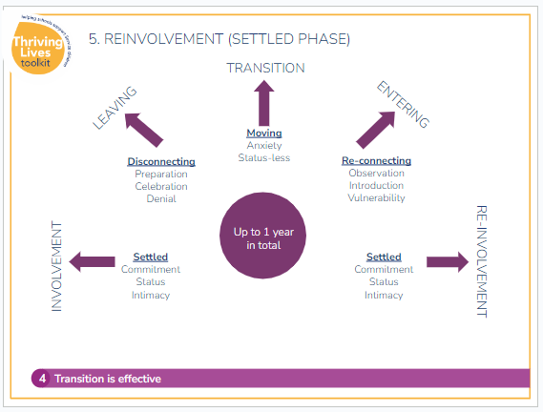

As this illustration from the Thriving Lives Toolkit shows, the impact of moving can have a significant impact upon a child’s experience.

Indeed, the whole process, from the ‘Settled, Involvement’ stage to the ‘Settled, Re-Involvement’ stage, can take up to a year.

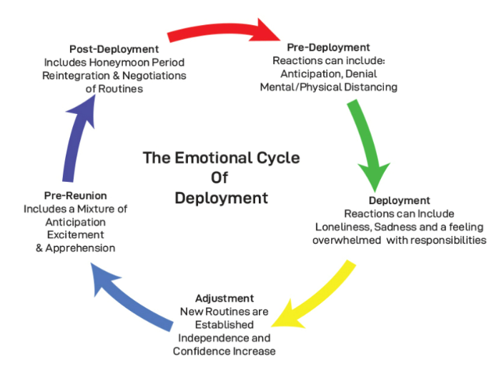

As can be seen from this diagram, there are many challenges that face military families **before, during and after deployment**, not just the deployment itself, which is often the perception of non-military people. Anticipating these challenges is important to minimize the emotional trauma caused by extended deployment.

**What is it like to be a child who stays?**

As opposed to many of our service pupils who move on to new schools and are perhaps only with us for a short while, many of our non-military children often see their entire primary education through with us. They face different challenges, not least having to adapt to their friends leaving. We offer pastoral support to all our pupils, celebrating the friendships that are made as well as helping children to say goodbye and adapt to life without their friends.

“I have had to say goodbye to so many friends who have moved away. It makes me sad as I don’t know if I’ll get to see them again.”